NEW BOOK AVAILABLE
LIVING LOVE, THE YOGA OF YAMA & NIYAMA
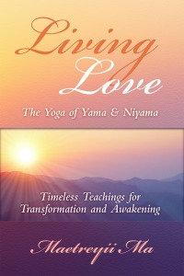
Timeless Teachings for Transformation and Awakening
By Maetreyii Ma

Living Love is practical mysticism at its best! It can help anyone who is pursuing the path of personal and spiritual development. Living Love is a unique combination of the ancient wisdom of yoga and modern psychology. It addresses the deep workings of the mind… showing us how important it is to self-reflect on our day to day activities. It is a source of inspiration as well as a practical guidebook which you can use to meet the challenges of life. This book offers a simple and profound message that we can transform our lives through right living and awakening to our deepest nature.
It eloquently maintains the integrity of the ancient scriptures while bringing the teachings down to earth and.at the same time uplifting us into a sublime connection to our deepest truth.

PERSONAL TRANSFORMATION & SELF-HELP, PSYCHOLOGY AND COUNSELING, SPIRITUALITY
ISBN 978-0-9863047-1-2
192 Pages: $14.50
Publisher: Ananda Gurukula
anandagk@comcast.net

ORDER YOUR BOOK TODAY

Maetreyii Ma, Megan Nolan Ph.D. has been doing yogic meditation and bringing through a loving Divine presence and spiritual knowledge from source for many years and compiling the teachings in books.
In addition to being an author, Maetreyii Ma is a licensed psychologist with a doctorate in Transpersonal
Psychology, a teacher of yogic philosophy and ancient wisdom, an ERYT 500 Yoga Teacher, and an ordained Yogic Minister, Acharya.

Available From Ingram Spark, New Leaf Distributors, Amazon
www.Yogama.info

